EXAMPLES :

✅ STEP-BY-STEP GUIDE:

1. Open Visual Studio Code
Launch VS Code on your computer.

2. Open Your React App in VS Code
Drag and drop your React app folder into the VS Code window.
Example folder name: my-app

3. Open the App Component
Inside VS Code:
Go to the src folder.
Open the App.js file.

4. Replace the Code in App.js
Remove the existing content and replace it with the following clean and commented code:
// Importing React library to use JSX and component features
import React from 'react';

// Define a functional component named 'abc'
function abc() {
// This component returns a simple heading
return <h1>UPSKILL</h1>;
}

// Export the component so it can be used in other files (like index.js)
export default abc;

5. Save the File
Press Ctrl + S (or Cmd + S on Mac) to save your changes.

6. Check in the Browser
Open your browser window where the React app is running (http://localhost:3000 by default).
You should now see: UPSKILL

✅ NOTE:
If you don’t see the update:
Make sure your development server is running.
Use: npm start
in the terminal from the root of your project directory.
- JSX, which stands for JavaScript XML, is a syntax extension for JavaScript that allows you to write HTML-like code within JavaScript.
It was initially created by Facebook for use with React and has since been adopted by multiple web frameworks.
JSX makes it easier to write and add HTML in React applications by converting HTML tags into React elements.

- Basic Usage of JSX
JSX allows you to write HTML elements directly within JavaScript and place them in the DOM without using
methods like createElement() or appendChild(). Here is an example of JSX:
const element = <h1>Hello, world!</h1>;
This code snippet creates a React element that renders an <h1> tag with the text "Hello, world!".
10 complete React component examples

✅ HOW TO USE EACH EXAMPLE:
- Open VS Code
- Drag your React app into VS Code
- Open src/App.js
- Replace its content with any one of the examples below
- Save (Ctrl+S) and check in your browser at http://localhost:3000

SIMPLE EXAMPLES
App.css
header img{
border-radius: 50%;
}

App.js
import logo from './images/A1.gif';
import './App.css';

function App() {
return (
<div className="App">
<header className="App-header">
<img src={logo} className="App-logo" alt="logo" />
<p>
Chhota Bheem
</p>
<a
className="App-link"
href="https://reactjs.org"
target="_blank"
rel="noopener noreferrer"
>
Learn React
</a>
</header>
</div>
);
}
export default App;

🔹 Example 2: Display a heading
import React from 'react';

function App() {
return <h1>Welcome to React!</h1>;
}

export default App;

🔹 Example 2: Display paragraph and line break
import React from 'react';

function App() {
return (
<div>
<h2>B6 & B7 : Learning React</h2>
<p>This is a paragraph in React.</p>
</div>
);
}
export default App;

🔹 Example 3: Use Variables
import React from 'react';

function App() {
const userName = "Baburao Ganapat Apate";
return <h1>Hello, {userName}...</h1>;
}

export default App;
// OUTPUT :
// Hello, Baburao Ganapat Apate...

2]MODERATE EXAMPLES

🔹 Example 4: Dynamic Date & Time
import React from 'react';

function App() {
const date = new Date().toLocaleString(); // Variable
return <h2>Current Date and Time: {date}</h2>;
}

export default App;
// OUTPUT :
// Current Date and Time: 2/18/2026, 2:57:58 PM

🔹 Example 5: Conditional Rendering
import React from 'react';

function App() {
const isLoggedIn = true;
const isLoggedOut = false;
return (
<div>
{isLoggedIn ? <h1>Welcome Back!</h1> : <h1>Please Login</h1>}
{isLoggedOut ? <h1>Welcome Back!</h1> : <h1>Please Login</h1>}
</div>
);
}

export default App;
// OUTPUT :
// Welcome Back!
// Please Login

🔹 Example 6: Simple Button Event
import React from 'react';

function App() {
const handleClick = () => {
alert("Button Clicked!");
};

return <button onClick={handleClick}>Click Me</button>;
}

export default App;
// OUTPUT :
// After Clicking BUTTON --> It will create ALERT with "Button Clicked!" Text

3]ADVANCED / DECORATED EXAMPLES

🔹 Example 7: Styled Card UI
import React from 'react';

function App() {
return (
<div style={{
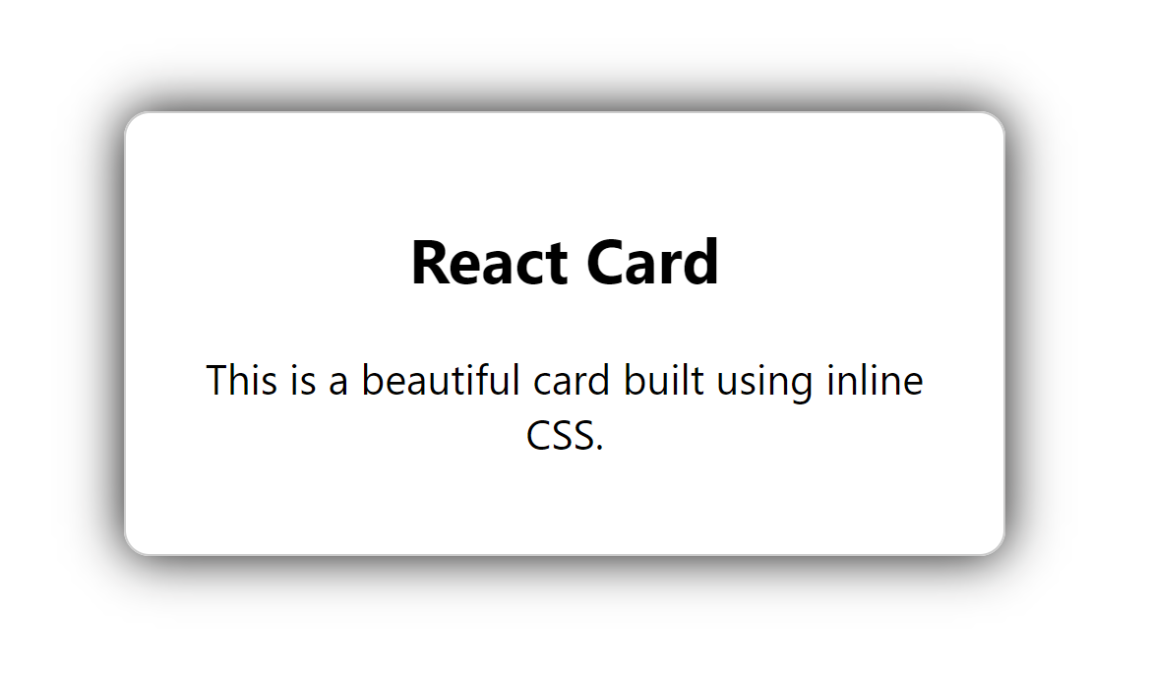
border: "1px solid #ccc",
padding: "20px",
borderRadius: "10px",
width: "300px",
margin: "50px auto",
textAlign: "center",
boxShadow: "0 0 20px rgba(10, 9, 9, 1.0)"
}}>
<h2>React Card</h2>
<p>This is a beautiful card built using inline CSS.</p>
</div>
);
}

export default App;
// OUTPUT : beautiful card

🔹 Example 8: Profile Card Component
import React from 'react';

function App() {
const name = "Arvind Bhosale";
const bio = "Frontend Developer at TCS";
const avatar = "https://media.simpleviralgames.com/images/vip-avatars/3fda10.png";

return (
<div style={{
border: "1px solid gray",
borderRadius: "12px",
padding: "20px",
width: "250px",
margin: "auto",
textAlign: "center"
}}>
<img src={avatar} alt="Avatar" style={{ borderRadius: "50%", height:"100px", width:"100px" }} />
<h2>{name}</h2>
<p>{bio}</p>
</div>
);
}
export default App;

Example : 2
import logo from "./logo.svg";
import "./App.css";

function App() {
const name = "Arvind Bhosale";
const bio = "Frontend Developer at PUNE";
const avatar = "https://media.simpleviralgames.com/images/vip-avatars/3fda10.png";
return (
<div className="App">
<header className="App-header">
<div style={{
border: "1px solid gray",
borderRadius: "12px",
padding: "20px",
width: "250px",
margin: "auto",
textAlign: "center",
}}
>
<img src={avatar} alt="Avatar" style={{ borderRadius: "50%", height: "100px", width: "100px" }}/>
<h2>{name}</h2>
<p>{bio}</p>
</div>
</header>
</div>
);
}
export default App;

🔹 Example 9: Dynamic List Rendering
import React from 'react';

function App() {
const fruits = ["Apple", "Banana", "Mango", "Pineapple"];
return (
<div>
<h2>Fruit List</h2>
<ul>
{fruits.map((fruit, index) => (
<li key={index}>{fruit}</li>
))}
</ul>
</div>
);
}

export default App;

🔹 Example 10: Animated Styled Text (CSS + React)
import React from 'react';
import './App.css'; // Make sure to create App.css in src/

function App() {
return <h1 className="animated">✨ Welcome to React World ✨</h1>;
}

export default App;
➡️ In App.css (create this file inside src/):
.animated {
text-align: center;
margin-top: 100px;
font-size: 2.5rem;
animation: glow 1s infinite alternate;
color: #4A90E2;
}

@keyframes glow {
from {
text-shadow: 0 0 10px #4A90E2;
}
to {
text-shadow: 0 0 20px #4A90E2, 0 0 30px #007BFF;
}
}

